Памятка

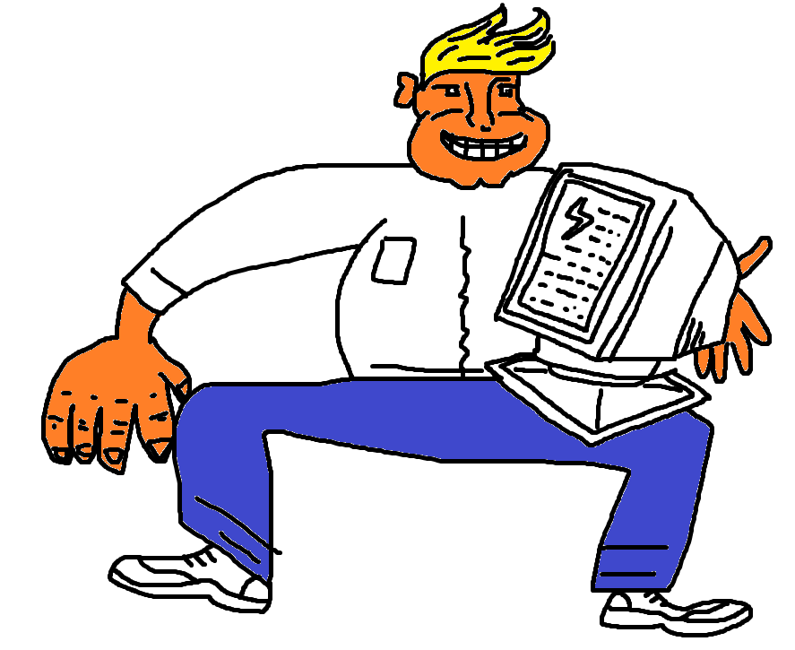

Тест https://docs.google.com/forms/d/10Uh2Ffdx9VtywWCFf-jV6hiyMlRt7fR1zGeO4pTKMLA/edit

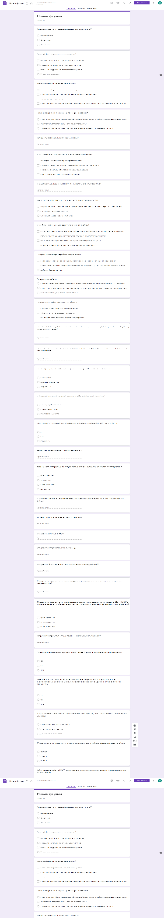

Презентация

